**Design & Technology**

**

**Wood processes**

**Materials required for questions**

* Pencil
* Rubber
* Calculator

**Instructions**

* Use black ink or ball-point pen
* Try answer all questions
* Use the space provided to answer questions
* Calculators can be used if necessary
* For the multiple choice questions, circle your answer

**Advice**

* Marks for each question are in brackets
* Read each question fully
* Try to answer every question
* Don’t spend too much time on one question

**Good luck!**

**Q1.** What is a key advantage of steam bending timber?

**A** Requires no specialised equipment

**B** Allows for tight curves without weakening the wood

**C** Suitable for mass-producing flat panels

**Q2.** Which machine process is used to create cylindrical timber components like table legs?

**A** Milling

**B** Routering

**C** Turning

**Q3.** Which joint is quick to assemble and common in flat-pack furniture?

**A** Mortise and tenon

**B** Half-lap joint

**C** Knock-down (KD) fittings

**Q4.** What type of screw is designed to create its own thread in pre-drilled timber?

**A** Machine screw

**B** Coach bolt

**C** Wood screw

**Q5.** Name 2 wood joints that could have been used for the wooden chair below **(2 marks)**

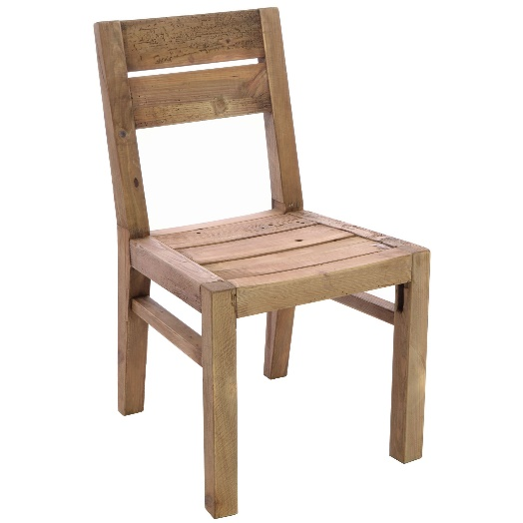

1.

2.

**Q6.** Describe the process of forming a timber product using lamination **(6 marks)**

**Answers**

**Q1**. B

**Q2**. C

**Q3**. C

**Q4**. C

**Q5**.

* Dowel joint
* Mortise and tenon joint
* Butt joint
* Housing joint

**Q6.**

* Several thin layers of veneer or thin plywood (1.2 mm – 3 mm thickness) can successfully be combined to the required thickness
* Adhesive is placed between each layer
* A two part former is used and pressure applied with clamps or a press while the lamination dries
* Excess adhesive from the moulding process can be removed
* A bag press or vacuum bag could be used with a styrofoam mould or equivalent former
* Simple curved shapes can be achieved
* Cross linked adhesive or ‘cascamite’ can be used to create a stronger glued joint
* Lamination can be trimmed to size once formed
* Laminated products can also be achieved by combining several sheets of kerfed flexible MDF.